PROPOSAL FOR FINANCIAL ASSISTANCE UNDER CLIMATE CHANGE FUND OF GUJARAT (CCFG), 2026–27
AI-Based Heatwave Early Warning and Health Risk Prediction System
1. EXECUTIVE SUMMARY
Climate change is one of the greatest threats to sustainable development, public health, and environmental management. Heatwaves are among the most dangerous and rapidly increasing climate hazards worldwide. Climate models have consistently forecast that extreme heat events will become more frequent and more intense, with longer durations, in recent decades and under future warming. The Intergovernmental Panel on Climate Change (IPCC) has consistently reported increased frequency, intensity, and duration of extreme heat events in past decades and projects further increases under future warming scenarios. Heatwaves significantly affect human health and wellbeing, labour productivity, urban infrastructure, energy consumption, water resources, and social and economic vulnerability and resilience.
India's tropical climate, large population, rapid urbanization, and dependence on outdoor economic activities make it vulnerable to extreme heat events. Heat waves have also become more intense and frequent, particularly over western India, including Gujarat, in recent decades. During the summer season, temperatures in the state regularly exceed 45°C, endangering a third of the population. Groups at particular risk, including older people, children, outdoor workers, low-income families, and individuals with chronic medical conditions, are at increased risk during heat extremes.
The State of Gujarat has been leading the way in heat adaptation planning in India through innovative initiatives such as the Ahmedabad Heat Action Plan. These activities have significantly increased the population's awareness and preparedness for heat risks and consequences, but warning systems remain mostly meteorological and largely dependent on heat thresholds. Many of these methods do not consider local vulnerability, adaptive capacity, population sensitivity, access to healthcare, or socio-economic factors that can affect health outcomes from heat exposure. Thus, decision support systems that combine climate, health, demographic, and geospatial data are needed to provide more precise, actionable heat-risk intelligence.
Proposed research will utilize several data sets, including historical weather data, remote sensing products, publicly available health indicators, aggregated indicators of health status, socio-demographic data derived from the Census, and land-use and health infrastructure indicators. Advanced machine learning methods (Random Forest, XGBoost, Long Short-Term Memory (LSTM) neural networks) will be employed to uncover complex non-linear relationships among climatic, environmental, and health variables. These models will also enable more detailed heat-wave predictions and more sophisticated health-risk classifications than threshold-based approaches.
A special feature of the project will be the development of a Heatwave Health Risk Index (HHRI) that combines three vulnerability factors: exposure, sensitivity, and adaptive capacity. The project will create district- and city-level heat-health vulnerability maps using Geographic Information Systems (GIS) and spatial analytics, and highlight hotspots that require priority interventions. The project will also design a web-based decision-support dashboard and a mobile alert system to support effective, timely dissemination of disaster information to government institutions and other stakeholders.
The project deliverables include a mobile alert system, a decision-support dashboard, Health-risk vulnerability maps, a Heatwave Health Risk Index, a health-risk prediction system, an AI-based heatwave forecasting model, technical reports, policy briefs, and scholarly publications. The project will directly support Gujarat's climate adaptation priorities, strengthen institutional capacity to manage heat risk, and build an evidence base to inform future policy and investment in Gujarat's climate-health space.
The proposed initiative also supports the goals of the Climate Change Fund of Gujarat, the State Action Plan on Climate Change (SAPCC), India's Nationally Determined Contributions (NDCs), and the Sustainable Development Goals (SDGs), especially SDG 3 (Good Health and Well-Being), SDG 11 (Sustainable Cities and Communities) and SDG 13 (Climate Action). The project seeks to create a methodology for climate-resilient governance that is both replicable and scalable across Gujarat and India.
2. BACKGROUND AND CONTEXT
Climate change is one of the great issues facing today's global society and is affecting nature, the economy, and living standards in ways never seen before. Climate change has altered weather patterns, the frequency of extreme climatic events, and environmental risks worldwide. The impacts of heatwaves on public health, productivity, infrastructure and livelihoods have become a growing concern, particularly given these climate-related hazards.
Heatwaves are extended periods of abnormally high temperatures above normal (i.e., average) temperatures for the area and season. Unlike sudden disasters such as earthquakes, cyclones, and floods, heatwaves are called a “silent disaster” because they develop gradually, cause significant mortality and morbidity, and not all affected individuals may be reported. The World Meteorological Organisation (WMO) states that, globally, heat-related hazards are among the major causes of weather-related mortality. The IPCC's Sixth Assessment Report shows that extreme climate events, such as extreme heat, are becoming more frequent and more intense, primarily due to anthropogenic climate change.
India is one of the countries highly prone to heat waves. The country's geographic position, climate, very rapid urbanisation, population density, and socioeconomic inequalities form a complex risk environment. In the last two decades, a few serious heat waves have occurred in various regions of India, leading to death tolls of several thousand, large-scale health emergencies, and economic losses. The India Meteorological Department (IMD) has reported more frequent and longer heatwaves, especially in the country's western and central regions.
Gujarat holds a special position in India in terms of climate vulnerability. Semi-arid and arid climate zones, coupled with heavy industrialization, urbanization, and dependence on agriculture/agricultural activities, increase the state's exposure to extreme heat. Areas in Ahmedabad, Rajkot, Surat, Vadodara, Kutch, Jamnagar, and Bhavnagar often experience much hotter summers, with temperatures exceeding 45°C. Climate projections also indicate that the likelihood of heatwave days and extreme temperatures will rise significantly over the next 30 years.
Extreme heat affects more than physical comfort. Heatwave health effects include heat exhaustion, heat stroke, dehydration, cardiovascular disease, respiratory disease, kidney disease, and increased mortality. Due to limited access to cooling and medical facilities, as well as limited adaptive capacity, various vulnerable populations are disproportionately affected by climate change. Laborers are especially vulnerable to heat-related illness and production losses, particularly outdoor workers in construction, agriculture, transportation, and casual work.
Urbanization compounds heat-related risks. The urban heat island is the phenomenon in which urbanized areas have temperatures substantially higher than non-urbanized areas due to rapid urban growth, decreasing green spaces, greater energy use, and land-use changes. Over the past few decades, Gujarat's major cities have grown significantly, increasing the demand for effective urban heat management.
Gujarat is taking measures to adapt to extreme heat amid the growing threat. The Ahmedabad Heat Action Plan 2013 is considered one of the first comprehensive Heat Adaptation Strategies implemented in South Asia. The plan includes early warning systems, public awareness raising, capacity building, and emergency response. Follow-on work has extended the heat adaptation planning to more districts and urban centres.
However, several issues remain. Most current warning systems still rely on weather thresholds and blanket warnings. These systems do not necessarily include local vulnerability assessments, healthcare access, socioeconomic data, demographic information, or health risk prediction models. As a result, identifying high-risk populations and prioritising interventions has been limited.
New technologies, such as artificial intelligence, machine learning, geospatial systems, and climate informatics, provide unprecedented opportunities to overcome these limitations. Advanced analytic tools can take large datasets on climate, environmental, demographic, and health-related conditions and provide more localised, precise forecasts. These technologies can integrate multiple data sources, enabling decision-makers to derive actionable intelligence for specific interventions and resource allocation.
In this context, the proposed project aims to develop a Climate Risk Early Warning and Health Risk Prediction System using AI, tailored to Gujarat's unique climatic, institutional, and demographic context. The project addresses a policy need and contributes to scientific understanding and innovation in climate adaptation.
3. LITERATURE REVIEW
3.1 Climate Change and Extreme Heat Events
The scientific literature has already documented a strong link between temperature, climate change, and the rise in heatwaves. Global mean surface temperatures have increased by ~1.1°C above pre-industrial levels, with a substantial increase in extreme heat events across most of the world (IPCC, 2023). The probability of extreme heatwaves is increasing, and they are likely to become even more common in the future climate. Extreme heatwaves that once occurred every 50 years are now much more common, and they are projected to become even more frequent in the future climate.
Research across Asia shows that South Asia is becoming one of the world's most heat-sensitive regions, given its population density, climate, and limited capacity for adaptation. Research indicates that billions of people will experience heat stress in the near future, potentially leading to life-threatening conditions as temperatures and humidity rise.
Heatwave frequency, duration and intensity are increasing in several studies in India. Mishra et al. (2020) observed an increase in extreme temperature events over western India, whereas Rohini et al. (2016) did not provide a regional analysis for eastern India. Gujarat is likely to face significant climate impacts, with the number of heat wave days rising by the end of the Century under moderate and high emission scenarios.
3.2 Health Impacts of Heatwaves
Epidemiological and environmental health research has focused on heatwaves' impacts on public health. Several studies have shown strong associations between high temperatures and poor health outcomes. Heat exposure directly causes heat cramps, heat exhaustion, dehydration, and heatstroke, and it worsens underlying cardiovascular, respiratory, and renal conditions.
In a systematic review, Mora et al. (2017) identified heat as one of the highest-priority threats to human health from climate change. Similar findings apply in other parts of the world, such as developing nations, where healthcare institutions and capacity may be limited.
Extreme heat is causing significant health burdens in India. India has seen evidence of serious health impacts due to extreme heat. Research in Ahmedabad has linked heightened mortality to severe heat waves. The study by Azhar et al. (2014) identified significant excess mortality from heatwave events in Ahmedabad and underscored the need for early warning and adaptation planning.
Not everyone is equally exposed to potential heat-related health risks. The vulnerability of older adults, children, those who are pregnant, those who work outside the house, low-income families and people suffering from chronic diseases is disproportionately high. Contextual risk factors, such as socio-economic status, housing quality, cooling measures, and access to healthcare, play a substantial role in vulnerability outcomes.
3.3 Heat Action Plans and Heat-Health Early Warning Systems
Heat Action Plans (HAPs) are among the most successful adaptation tools for mitigating heat-related deaths and illnesses globally. In response to the extreme heatwave events in Europe in 2003, several countries developed a heat-health warning system that combined meteorological forecasts, public health preparedness planning, risk communication, and emergency response plans (Lowe et al., 2011). A later assessment of the effectiveness of HAPs found that they are highly effective in minimizing heat-related fatalities, especially when properly designed, with effective communication messages and organizational coordination (Toloo et al., 2013).
As discussed this week, incorporating epidemiological thresholds into Heat-Health Warning Systems (HHWS) is becoming more common, at least in the United States and Europe. However, evidence suggests that health-based thresholds are better triggers for intervention because they capture both local vulnerability characteristics and health outcomes, not just meteorological conditions (Hajat et al., 2010). Studies in France, Germany and Canada have shown that enhanced heat-health warnings effectively increase preparedness among health care providers and vulnerable communities and reduce mortality during extreme heat periods (e.g., Laaidi et al., 2012).
Ahmedabad has been recognized as one of India's pioneering cities in urban heat adaptation by its Heat Action Plan (HAP) (2013). The Ahmedabad Municipal Corporation, along with the Indian Institute of Public Health-Gandhinagar and external partners, developed the HAP as a framework with four major components: early warning systems, public outreach, healthcare preparedness, and inter-agency coordination (Hess et al., 2018). Assessments of the Ahmedabad model indicate that heat-related mortality substantially decreased after heat adaptation was implemented, showing that proactive heat adaptation is effective (Knowlton et al., 2014).
The National Disaster Management Authority (NDMA) and the India Meteorological Department (IMD) have observed Ahmedabad's success. They are therefore urging other Cities and States in India to implement Heat Action Plans. However, several recent assessments reveal that most current plans remain overly guided by temperature alerts and generic guidance, without incorporating demographic vulnerability, access to healthcare, socio-economic inequalities, or locally specific risk factors, among others (Singh et al., 2023).
Sharma & Mujumdar (2021) also reviewed heat adaptation strategies in South Asia and found that less effort is devoted to identifying populations at very high risk and prioritizing adaptation actions, as early warning systems still focus on hazard detection rather than risk prediction. Hence, there is a growing call to integrate heat-health warning systems that incorporate vulnerability assessments, public health analyses, and meteorological forecasts (Ebi et al., 2021).
3.4 Artificial Intelligence and Machine Learning in Climate Risk Prediction
As climate and environmental data become more available, Artificial Intelligence (AI) and Machine Learning (ML) techniques are gaining widespread use in climate science and disaster risk management. While many traditional statistical forecasting methods fail to account for nonlinear relationships among climatic variables, machine learning's ability to process large amounts of data enables it to capture complex relationships and predict climatic variables more accurately than conventional statistical models (Reichstein et al., 2019).
Some of the most popular machine learning models for climate forecasting are Random Forest, Support Vector Machines, Extreme Gradient Boosting (XGBoost), Artificial Neural Networks (ANNs) and Long Short-Term Memory (LSTM) networks. Since the algorithm is robust to multicollinearity and can easily capture nonlinear relationships, Random Forest algorithms are efficient for prediction and similar environmental tasks (Breiman, 2001). XGBoost is a popular model that is more accurate and computationally more efficient, especially for large-scale datasets in environmental applications (Chen & Guestrin, 2016).
Deep learning methods, such as LSTM networks, can handle temporal relationships and sequential patterns in time-series data, making them well suited to climate prediction. Research in China, Australia, and the USA has shown that LSTM-based models excel at predicting temperature anomalies, extreme heat, and climate variability compared with traditional statistical models (Qin et al., 2017; Li et al., 2022).
Another machine learning method is increasingly used in climate-health research. For example, Xu et al. (2020) created AI predictive models for heat-related hospital admissions using meteorological and demographic data. Similarly, during extreme heat events, Bunker et al. (2023) demonstrated the effectiveness of machine learning algorithms in distinguishing high-risk populations using climatic, socio-economic, and health indicators.
Recent developments in Explainable Artificial Intelligence (XAI) have made machine learning for public-sector decision-making more feasible. Methods such as SHAP (SHapley Additive Explanations) can help researchers better understand the relative importance of factors affecting model predictions and improve the transparency and interpretability of explanations (Lundberg & Lee, 2017). Essential skills in climate adaptation scenarios: decision-makers must make decisions based on scientifically sound, open evidence.
AI is advancing rapidly worldwide, but Indian programs for weed management are still in the works. Though various milestones have been achieved globally with AI, there is still much progress to be made in India in managing heat waves. Previous studies have mainly focused on weather prediction rather than on integrated climate-health risk prediction. Moreover, few studies have explored how to operationalize AI models in decision support systems at the city and district level, in government settings.
3.5 Geospatial Technologies and Heat Vulnerability Assessment
Spatial technologies such as Geographic Information Systems (GIS), remote sensing, and spatial analytics have become vital tools in addressing climate vulnerability and supporting adaptation planning. These technologies enable the integration of environmental, demographic, infrastructural, and socio-economic data into a spatial framework, helping identify areas of climate risk and vulnerable populations (Malczewski, 2006).
Over the last 20 years, the concept of heat vulnerability assessment has undergone much transformation. Early studies primarily used exposure indicators such as land surface temperature (LST) and air temperature (AT). The contemporary definition of vulnerability, however, is more complex and impacted by demographic, social, economic, environmental and institutional factors (IPCC, 2023).
The exposure-sensitivity-adaptive capacity framework is probably one of the most important conceptual frameworks. Under this approach, climate vulnerability involves a population's characteristics and capacity to adapt to climate change, as well as exposure to climate hazards (IPCC, 2023).
Several researchers have made it workable by devising a "Heat Vulnerability Index" (HVI). Reid et al. (2009) developed one of the first models to identify vulnerable communities in the United States, using various demographic, socio-economic, and environmental indicators. A comparable strategy has then been adopted in other parts of the world, from Europe to Australia, China and Southeast Asia.
Land surface temperature (LST), vegetation cover, built-up density, albedo, and impervious surfaces are among the few remote sensing indicators that help quantify climate-related impacts in urban areas. Satellite sensors such as Landsat, Sentinel, and MODIS have been extensively used to measure the magnitude of the urban heat island and heat-stressed areas (Weng et al., 2004).
Advanced spatial analytical techniques, including hotspot analysis, Moran's I statistic, Geographically Weighted Regression (GWR), and spatial clustering algorithms, have improved this work. These methods can pinpoint areas of vulnerability and study spatial patterns among climate, environmental, and socio-economic factors (Fotheringham et al., 2002).
Geospatial-based heat vulnerability assessments in India remain comparatively small in scale and have limited geographic coverage. Most existing studies are conducted in metros such as Hyderabad, Ahmedabad, Delhi, and Kolkata. Only a handful of studies have done statewide analysis combining climatic, health, demographic, and adaptive capacity variables. Furthermore, the incorporation of geographic information systems (GIS)-based vulnerability mapping with AI-based forecasting in India remains underexplored.
3.6 Synthesis of Literature
The above literature review identified four key themes. First, the frequency, duration, and severity of heatwave events are escalating worldwide, including in India, due to projected climate change. Second, climate extremes are projected to become more frequent, longer-lasting, and more intense, posing significant threats to people's health and economic productivity.
Second, current Heat Action Plans and warning systems have proven effective at reducing heat-related mortality in most areas. They are primarily hazard-oriented rather than providing a full risk assessment, focusing mostly on temperature thresholds.
Third, the tremendous progress in artificial intelligence and machine learning offers opportunities, as never before, to enhance heatwave forecasting and health risk prediction by incorporating diverse datasets and employing nonlinear modelling techniques.
Third, GIS and spatial analytical tools help identify vulnerable populations and implement targeted adaptation interventions. Current applications remain fragmented and infrequently use climate, health, demographic, and adaptive capacity indicators within a common operational framework.
The observations show the need for multidisciplinary efforts to integrate climate science, public health, artificial intelligence, and geospatial analysis to enable evidence-informed heat adaptation planning.
4. RESEARCH GAP AND NEED ASSESSMENT
However, the literature documents significant developments in knowledge on heatwave dynamics, health impacts, vulnerability assessment, and adaptation planning. However, some important research and operational gaps remain, especially in the context of Gujarat.
Gap 1: Predominantly Hazard-Centric Warning Systems
Current heatwave warning systems in India largely rely on meteorological criteria such as maximum and minimum temperatures, the heat index, and other heat-related parameters (Singh et al., 2023). Such systems are effective for alerting people to hazardous weather but do not account for differences in vulnerability, adaptive capacity, and health and social service provision at the population level. Therefore, the health impact of such heat events can vary greatly from one region to another.
Gap 2: Limited Integration of Climate and Health Data
Several studies have examined heat-wave occurrence, and some have focused on health effects. However, few studies have merged climate, health, demographic, and environmental datasets into a common analytical framework (Ebi et al., 2021). This limitation makes it difficult to interpret the intricate interplay among factors in heat-related risk.
Gap 3: Lacking Localized Vulnerability Assessment
Current studies on heat vulnerability in India are confined to a few metros. Vulnerability assessments at the district and city levels remain limited and do not account for Gujarat's diverse climate and socio-economic conditions. As a result, policies lack detailed spatial information for targeted adaptation planning.
Gap 4: Underutilization of Artificial Intelligence
While machine learning methods have shown significant predictive capacity in environmental forecasting, their use in heat-health forecasting in India remains limited (Reichstein et al., 2019). Advanced AI models that combine climatic, demographic, and health indicators are uncommon for forecasting health effects.
Gap 5: Lack of Operational Decision-Support Systems
Vulnerability assessments or predictions often appear only at the end of academic studies, with no operational tools to help government agencies during heat emergencies. The scientific community has a long way to go before it can directly inform decision-making.
Gap 6: Absence of Integrated Climate-Health Intelligence Platforms in Gujarat
As far as is known, Gujarat lacks a statewide platform that integrates heatwave forecasting, health risk prediction, and vulnerability mapping and can be fed with decision-support capabilities. Significant institutional and technological deficits hinder anticipatory climate adaptation planning.
Need for the Proposed Project
The proposed AI-Based Heatwave Early Warning and Health Risk Prediction System targets these gaps. The project combines meteorological data, health indicators, demographic and adaptive-capacity variables, geospatial information, and machine learning methods, moving beyond hazard forecasting to full climate-health risk prediction.
The project will provide benefits, including useful information for governance, evidence-based adaptation planning, and enhanced institutional capacities, among others, in support of the climate-resilient development of Gujarat. Moreover, the proposed framework can be replicated in other Indian states and elsewhere in the world where climate change is an issue.
5. PROJECT OBJECTIVES
5.1 Overall Objective
The end-to-end goal of the proposed project is to increase climate resilience and public health preparedness in Gujarat by developing an Artificial Intelligence-Based Heatwave Early Warning and Health Risk Prediction System to forecast climate change-induced heatwave events, assess population vulnerability, and enable evidence-based decision-making.
5.2 Specific Objectives
The project aims to have several specific outcomes, including but not limited to:
Objective 1: To analyse spatial and temporal patterns, trends, frequency, duration, and intensity of heatwave events over Gujarat using historical meteorological and climate data.
Objective 2: To analyse the association between heat exposures and available publicly reported aggregated health indicators across selected districts/urban centres to gain insight into the interactions between heat and health.
Objective 3: Develop and validate advanced AI & machine learning models to predict the occurrence of heatwaves and associated health-risk categories.
Objective 4: Develop a multidimensional Heatwave Health Risk Index (HHRI) that combines indicators of exposure, sensitivity, and adaptive capacity.
Objective 5: Create district- and city-level heat-health risk mapping and analysis using GIS.
Objective 6: Create an interactive decision-support dashboard and mobile alert system that government departments managing and adapting to climate change, as well as public health and disaster management, can use.
Objective 7: To develop high-quality scientific evidence, technical reports, policy recommendations, and academic publications to promote climate-resilient governance in Gujarat.
Objective 8: To develop a scalable and replicable climate-health intelligence framework that can be expanded to other climate hazards and geographic areas in the future.

6. ALIGNMENT WITH CCFG, SAPCC, NDCs AND SDGs

6.1 Alignment with Climate Change Fund of Gujarat (CCFG)
The proposed project aligns well with the goals of the Climate Change Fund of Gujarat. It develops a research- and development-based solution for climate adaptation to address one of the state's most pressing climate risks. The project builds evidence-based climate governance, institutional climate resilience, technological innovation, and climate adaptation planning and informed decision-making.
The project goes directly toward advancing priorities at CCFG, such as:
Improving climate resilience through anticipatory risk management.
• Aid in scientific evidence planning for adaptation.
AI, machine learning and geospatial technologies as drivers of innovation.
The building of institutional capacity for climate-responsive governance.
• Providing policy-relevant knowledge and tools for decision-making.
6.2 Alignment with State Action Plan on Climate Change (SAPCC), Gujarat
The State Action Plan identifies public health, urban resilience, DRR, and climate adaptation as key areas of climate change action in Gujarat. The proposed project directly addresses these priorities by improving heat-risk forecasting, vulnerability assessment, and institutional preparedness.
The project addresses several themes of the SAPCC, such as:
• Climate-resilient urban development.
• Public health adaptation.
• Disaster risk management.
• Climate information systems.
Capacity development and knowledge creation.
6.3 Alignment with India's Nationally Determined Contributions (NDCs)
India's NDCs focus more on enhancing adaptive capacity and climate resilience and on reducing vulnerability to climate change impacts. The proposed project directly supports these commitments by creating innovative adaptation resources and strengthening climate-risk management capacity.
The project supports:
• Climate adaptation planning.
• Resilience-building initiatives.
• Climate-informed governance.
• Science-based policy development.
6.4 Alignment with Sustainable Development Goals (SDGs)
The Project that is proposed will serve as a direct benefit to the following SDGs:
SDG 3: Good Health and Well-Being
The project aims to strengthen people's resilience to the health impacts of extreme heat by enhancing early warning systems, preparing EHS organizations, and providing targeted interventions.
SDG 11: Sustainable Cities and Communities
The project contributes to developing more resilient, climate-adaptive cities by mapping vulnerabilities and conducting urban heat risk assessments.
SDG 13: Climate Action
The project directly supports the campaign for adaptation and resilience to climate risks by creating innovative tools to manage these risks.
The first SDG Chapter is Industry, Innovation and Infrastructure.SDG 9 is Industry, Innovation and Infrastructure.
AI, ML, and digital decision support systems drive technological innovation and fortify the climate information infrastructure.
SDG 17: Partnerships for the Goals
The project aims to promote joint efforts among government agencies, academic institutions, public health organizations, and climate experts, advancing multi-stakeholder partnerships for sustainable development.
7. RESEARCH QUESTIONS AND HYPOTHESES
The proposed study aims to develop a scientifically sound and operationally useful modeling approach for heatwave prediction and identifying health risks across the entire state of Gujarat. To achieve this goal, the study will address the following questions.
7.1 Research Questions
RQ1: What are the spatial trends of heatwaves across Gujarat, and what are the temporal trends in the occurrence, intensity, duration, and frequency of heatwaves?
P2: What are the degrees of impact and susceptibility of human populations to heatwaves under different urban development patterns, land-use features, temperature, and humidity?
RQ3: How do heatwave features relate to publicly available aggregated health indicators by district and urban centre in Gujarat?
How well can AI & ML models predict heatwave and health-risk categories compared to the traditional threshold-based models?
RQ5: What is the best combination of climatic exposures, socio-demographic sensitivities, environmental conditions, and indicators of adaptive capacity that explains heat-health vulnerability at the sub-national scale in Gujarat?
RQ6: How can climate-health intelligence be applied to public health, disaster management, and climate adaptation planning through an operational decision-support tool for government agencies responsible for these actions?
7.2 Research Hypotheses
The following hypotheses will guide the empirical investigation, informed by a literature review and the conceptual framework of climate vulnerability assessment.
H1: Districts with greater heat exposure and smaller adaptive capacity scores will have significantly higher heat-health risk scores than districts with less heat exposure and greater adaptive capacity scores.
H2: By incorporating climatic, environmental, and socio-demographic factors, machine learning models will outperform traditional threshold-based models in predicting heatwave occurrences.
H3: With respect to vulnerability and health impacts, areas with higher built-up density, lower vegetation cover, and stronger urban heat island (UHI) effects will be substantially more vulnerable than those with lower levels of urbanization.
H4: The health risks of a heatwave depend not only on temperature extremes but also on demographic sensitivity factors, including age structure, population density, access to health care services, and socio-economic characteristics.
H5: Multi-attribute heat-health vulnerability models will account for heat impacts more successfully than meteorological-only models.
H6: Adopting an integrated climate-health decision-support system can improve anticipatory preparedness and resource allocation for managing climate hazards and risks.
8. CONCEPTUAL FRAMEWORK
The study will use the climate risk framework developed by the Intergovernmental Panel on Climate Change (IPCC), which considers climate risk as the interaction among hazard, exposure, vulnerability, and adaptive capacity (IPCC, 2023).
Regarding heatwaves, the risk is not solely due to high temperatures. Instead, risk is a function of three main dimensions:
Exposure: how heatwave conditions affect populations, infrastructure, and economic systems. Indicators include maximum and minimum temperatures, the heat index, heatwave length, land surface temperature, and urban heat island intensity.
Sensitivity: the vulnerability of populations to heat impacts. Demographic characteristics, health status, population density, age structure, occupational exposure, and socio-economic status influence it.
Adaptive Capacity: the ability of a person, community, or institution to prepare for, survive the physical impacts of heat stress, and adapt afterward. Some indicators include access to healthcare, emergency preparedness, green infrastructure, housing quality, literacy, and access to cooling systems.
It can be connected to other dimensions such as:
Exposure + Sensitivity − Adaptive Capacity = Heatwave Health Risk
The design sketch for the proposed research work is given below:
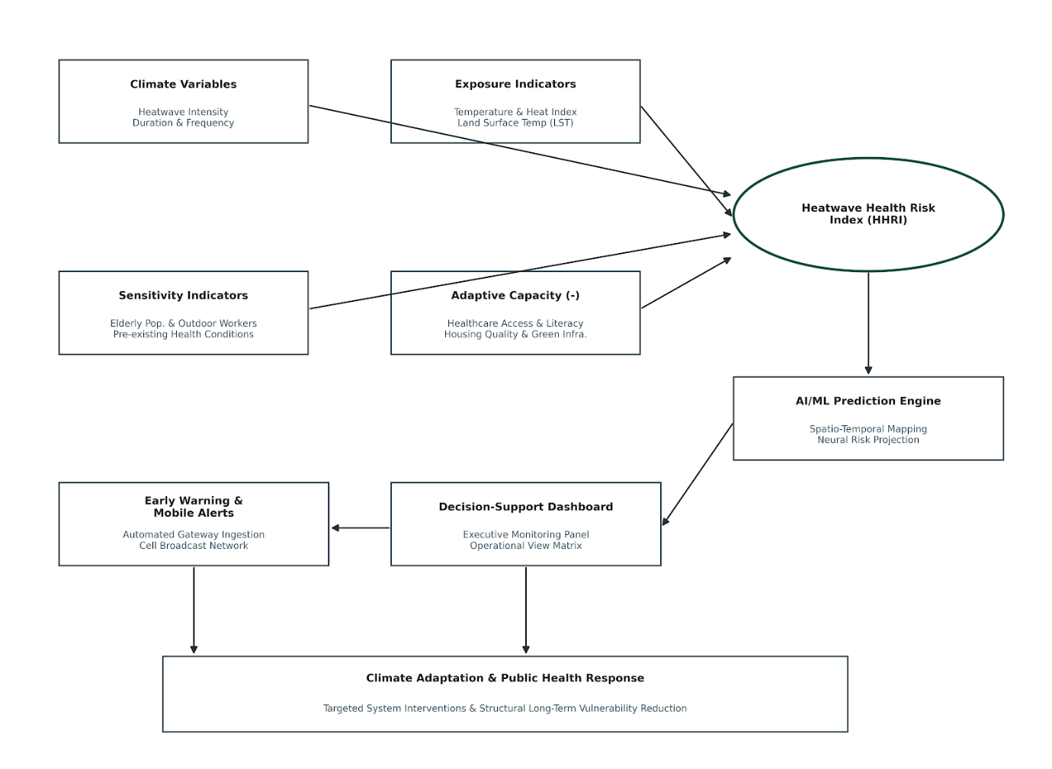
The framework serves as the basis for data selection, indicator creation, vulnerability mapping, designing and developing machine-learning models, and designing decision support systems.
9. DETAILED METHODOLOGY
9.1 Research Design
The anticipated study will present a research approach that integrates climate science, public health analytics, geospatial technologies, and artificial intelligence. The complexity of heatwaves means their effects extend beyond temperature and also depend on population vulnerability, environmental conditions, access to health care, and adaptive capacity. Multi-domain information must be integrated, and so multi-domain understanding and prediction of heat-related risks are needed.
The research will therefore take place in five interrelated areas. The study will analyse historical heatwave patterns across Gujarat to understand changes in the frequency, duration, and intensity of extreme heat events over time. The study will analyse historical heatwave patterns across Gujarat to understand changes in the frequency, duration, and intensity of extreme heat events over time. Second, and most importantly, the study will analyse the connection between climatic conditions and health outcomes to understand the impacts of climatic extremes on health. Third, AI and machine learning models will be developed to predict health risks during heatwaves and to anticipate their onset. Fourth, spatial analysis methods will identify geographical hotspots of vulnerability and create heat-health risk maps at the district and city levels. The scientific results will be incorporated into a decision-support dashboard and mobile alert system for government agencies.
This research design will ensure that the project yields scientific knowledge and operational tools useful for Climate Adaptation Planning and Public Health preparedness in Gujarat.
9.2 Study Area
The study will take place in selected districts/urban centres of Gujarat. Gujarat is an ideal region for climate-health research, with diverse climatic and environmental conditions, a wide range of socio-economic and demographic features, and frequent heatwaves.
District selection will be based on historical heatwave data, population exposure, urbanization intensity, data availability, and representativeness across climatic zones. The urban heat island effect is highly evident in urban centers such as Ahmedabad, Surat, Vadodara, and Rajkot. In contrast, Kutch and Banaskantha have severe climate conditions typical of semi-arid regions.
A multi-district approach will enable comparison of different heat-risk environments and support the development of a state-wide (across a city or region) framework.
10. SAMPLE SIZING AND PLANIFICATION
10.1 Meteorological Data
The proposed research will use meteorological data, since heatwaves arise from climate patterns. The historical climate data are collected from various national and international climate data organisations, including the India Meteorological Department (IMD), the ERA5 Reanalysis, the NASA POWER databases, and NOAA climate repositories.
The analysis will consider maximum temperature, minimum temperature, humidity, heat index, rainfall, solar radiation, and wind speed. These variables all affect human heat stress and are among the criteria used to rate the effects of a heatwave.
We will collect historical data for about 20 years to reflect long-term climatic trends and variability. Long-term datasets are important because they separate short-term weather variations from longer-term climate-related variations and trends. This historical background will enable us to determine whether the frequency, intensity, and duration of heatwaves have increased across various regions of Gujarat.
10.2 Health Data
One of the main goals of the project is not only to forecast heatwaves but also to understand their implications for public health. Thus, the study will combine all health indicators with climatic information.
The study will use publicly available data approved by institutions such as the Health Management Information System (HMIS), the Integrated Disease Surveillance Programme (IDSP), the National Health Mission database, and district-level public health reports to gather health-related information.
Analysis will centre on indicators such as heat-related injuries and hospital admissions, heart and lung diseases, respiratory ailments, and deaths. Because these indicators are strongly linked to extreme heat exposure, researchers have widely used them in climate-health studies.
The project will use telemedicine to analyze clinical data and weather variables to pinpoint temperature risks where they are greatest. This information can be specifically useful for planning efficient public health interventions or warning systems.
10.3 Socio-Demographic Data
Populations differ in their susceptibility to heatwave impacts. Similar temperatures in 2 districts can lead to very different health outcomes due to differences in age structure, income, housing, level of care, and occupational exposure.
In addition to socio-economic data from the Census of India, this study will include data from the National Family Health Survey (NFHS) and the Socio-Economic Caste Census (SECC) to capture dimensions of vulnerability.
The analysis will consider factors such as population density, literacy, poverty rate, age ratio, housing conditions, and occupational status. These factors can help assess a community's vulnerability to heat stress.
As an example, districts with high numbers of older people could be more susceptible to health risks due to the effects of heat-related illness on seniors. Similarly, districts with higher proportions of employees engaged in outdoor occupational activities may face greater exposure to extreme temperatures.
10.4 Spatial and Environmental Data
Environmental factors such as land cover, vegetation density, built-up areas, and urbanization patterns significantly influence heatwaves. These indicators can be derived from remote sensing and/or satellite data.
Landsat, Sentinel, MODIS, and NRSC Bhuvan data will be available for the project to derive indicators of land surface temperature, vegetation cover, urban density, and urban heat island intensity.
These data help scientists pinpoint areas where environmental factors exacerbate heat exposure. Highly urbanized areas with large amounts of concrete and fewer green spaces, for example, heat up longer and are therefore hotter than adjacent rural areas.
The project will produce joint spatial information on the dynamics of heat risks in Gujarat, alongside climatic and health data.
11. ANALYTICAL TECHNIQUES
11.1 Heatwave Trend Analysis
The first analytical aspect of the investigation concerns estimating and understanding the development of heat-wave conditions. The methodology for analyzing heatwave trends in frequency, duration, timing, and intensity will be explained using historical temperature data. Applying the Mann-Kendall Trend Test and Sen's Slope Estimator to the data will provide insight into the temperature trend and the rate of increase in heat waves. They are widely used in climate research because they identify long-term trends even when year-to-year fluctuations do not. In addition, seasonal decomposition will remove non-sea-state temperature variations to isolate exceptionally warm heat-wave events. The analysis will help explain inter-regional variability in climate risk in Gujarat.
11.2 Climate-Health Linkage Assessment
The project explores the links between heat exposure and disease outcomes. The study will therefore explore the impact of temperature on disease incidence, hospital admissions, and deaths. Correlation analysis will first identify relationships between climatic factors and health indicators. However, health impacts can appear several days after exposure to extreme temperatures. For example, a heat wave on one day may be correlated with a 2-3 day lag in hospital admissions. We will model these delayed effects using a family of models known as Distributed Lag Nonlinear Models (DLNMs). These models are considered among the “most complete” means of analysing the climate-health relationship, as they can incorporate delayed effects and nonlinear responses. This analysis will help assess temperature thresholds that pose a significant health threat and inform early-warning development.
11.3 Spatial Vulnerability Assessment. While forecasting heatwaves is helpful, policy actors should also be mindful of vulnerable regions. The spatial vulnerability assessment addresses this. To build maps of district- and City-level vulnerability, a combination of GIS-based indicators of exposure, sensitivity and adaptive capacity will be used. Principal Component Analysis (PCA) will identify the factors that most strongly influence vulnerability. Hotspot analysis techniques will then identify the high-risk areas. The maps will also help the government prioritize time and resources to address affected communities during heat waves, enabling effective interventions during acute heat waves.
12. AI/ML ARCHITECTURE
12.1 Why Artificial Intelligence?
Traditional heat wave forecasting tools rely on predefined thresholds. These systems can be useful, but they struggle to integrate the complex interrelations among climatic, environmental, demographic, and health determinants. There are indeed strong reasons to use Artificial Intelligence: AI can discover patterns in enormous datasets and reveal relationships you would not find in conventional analyses. The goal is not to replace current forecasting systems, but to complement their capabilities and support decision-making.
12.2 Random Forest Model
Random Forest is a collective machine learning technique that uses several decision trees to make predictions. The model incorporates numerous “expert views” and combines their predictions to yield a final prediction. This approach minimizes errors and improves reliability.
Random Forest models are important for determining which factors are most significant for heat wave occurrence and health effects.
12.3 XGBoost Model
XGBoost is among the most popular machine-learning methods for predictive analytics today.
As the model repeats the process, it learns from its errors and makes increasingly accurate forecasts. XGBoost is used in various applications, including climate forecasting, healthcare analytics, and financial modelling, given its accuracy.
XGBoost played a pivotal role in this project by predicting the occurrence of heatwaves and classifying them by risk level.
12.4: Long Short-Term Memory (LSTM)
LSTMs are a special form of neural network, trained for time-series prediction. Unlike traditional models, LSTMs can incorporate information from previous observations to improve future predictions. This characteristic also makes them well suited to climate forecasting, since weather and climate phenomena are time-dependent.
Hence, LSTM models will predict future atmospheric conditions during heatwaves using historical climate information.
12.5 Explainable Artificial Intelligence
A major drawback of AI systems is that predictions can be difficult to understand, even for a specific algorithm, without peering into the system's “black box” logic.
As a result, the project will use Explainable AI (XAI) methodologies, such as SHAP analysis, to address this problem. These methods help identify which variables most influence a prediction.
For instance, the system might show that land-surface temperature, humidity, and population density were the most significant factors in a given high-risk forecast.
This transparency is crucial for establishing trust among policymakers and for interpreting and validating AI-generated policy recommendations.
13. VALIDATION STRATEGY
Forecasting and decision-support systems are only useful if they are consistently accurate and reliable. If a potential government agency has confidence in the scientific soundness and reliability of a heatwave warning system, then it must be able to rely on that system. Thus, a detailed validation plan will be developed throughout the project to ensure that all outputs and models circulated have an acceptable degree of accuracy and robustness.
Model development will initiate the validation process. Processed historical datasets/observations (climate and health) will be separated into training and testing datasets. We will develop a forecasting model using the training dataset and test it on the testing dataset to verify performance against observations not used for development. This will help the model learn patterns, not just memorize past outcomes.
In addition, we will use various subsets of the data to evaluate model performance in a cross-validation setting. To ensure the model predicts a stable, reliable set of values rather than predictions that hold only for a single test, we will test it over time with multiple test sets. This process reduces the risk of overfitting, where the model performs well on historical data but performs differently when confronted with real-world data.
One critical aspect to validate will be historical testing. In this approach, the developed models will be used to analyse heatwave events in Gujarat. The goal is to determine whether these systems could predict them and the associated health risks. To understand how the system might work in practice before deployment, the team will compare model outputs with experience.
The latter will also conduct a sensitivity analysis to assess how the model's output varies with changes in input variables. For example, the analysis will examine how expected risk changes with a particular aspect of healthcare access, such as temperature, humidity, or population density. Many factors affect climate systems, and considerable uncertainty remains; sensitivity testing is important because it helps us understand variations in impacts.
To evaluate model accuracy, we will use several performance indicators: prediction error, classification accuracy, sensitivity, specificity, and forecasting reliability. Based on the metrics above, we will select the top-performing models for deployment in the decision support platform.
The validation will not be limited to technical performance. Consulting experts in climate science and public health, relevant practitioners in disaster management, and government representatives will review the outputs to assess their practical relevance. Their feedback will help to ensure that information is meaningful, legible, and supportive of decision-making for the system.
The proposed Heatwave Early Warning and Health Risk Prediction System aims to confirm the tool's effectiveness and improve its credibility and predictive capacity to support public health preparedness and adaptation decisions for climate change.
14. DECISION-SUPPORT DASHBOARD DESIGN
Most climate-related publications and studies do not break down or communicate the core results in ways that provide policy advice or other means of capturing and integrating climate science and adaptation. Outputs of this kind can be important for building scientific knowledge but may not translate easily into real-time decision-making by policymakers and operational agencies. The project will create an interactive decision-support dashboard to bridge the gap between research and practice by making complex scientific analysis more readily understandable and actionable.
The Dashboard will be a single, unified climate-health intelligence hub accessible to government departments, disaster management agencies, urban local bodies, and public health agencies. It will combine data from several sources and display it in clear visualisations, maps, indicators, and alerts.
The dashboard will enable real-time weather monitoring across Gujarat. Users will be able to access current temperature, Heat Index, Humidity, and Heatwave alerts for various districts and urban centres. This visual, user-friendly data will give decision-makers a snapshot of current conditions.
One of the dashboard's main elements will be forecasting. The system will provide short-term predictions of heatwaves and AI-generated health-risk categories. The dashboard will not only indicate whether temperatures will be above or below a threshold, but also assess the severity of their potential effects on populations and health systems.
The platform will also include GIS-based vulnerability maps. These maps will show spatial drivers of exposure, sensitivity, and adaptive capacity as district- and city-level variations. Users will be able to locate hotspots where populations face higher risks of heat exposure. This information is valuable for reaching vulnerable groups and for allocating and targeting resources and interventions.
Another key addition is health risk indicators. Using climate forecasts and vulnerability characteristics, the dashboard will estimate potential heat-related health impacts. This will help healthcare agencies and emergency teams plan proactively.
The dashboard will include a resource-planning module to support operational decision-making. This component could help planners determine where additional healthcare staff, cooling centres, emergency services, or public announcements are needed during the heat wave.
The dashboard will be built on a scalable, modular architecture. It will be embedded with other climate hazards, including drought, urban flooding, air pollution events, and vector-borne disease outbreak events. This method will ensure that investment under the Climate Change Fund of Gujarat continues to deliver long-term value beyond the project's scope.
The idea is for the dashboard to present the science that translates into climate adaptation action.
15. MOBILE ALERT FRAMEWORK
Communication is a vital part of effective heat-risk management, and much of it needs to happen at the right time. However, even the best forecasting system will have little value if it is not disseminated rapidly enough to those who need it to make decisions. The mobile alert framework (MAF) is one of the proposed project's recommendations, enabling fast, easy dissemination of heat-related risk information.
The alert system will use a three-tier alert framework, similar to international approaches to weather and disaster risk communication. Each alert level will correspond to a different degree of heat-related risk and enable the appropriate response actions.
If the climatic conditions are normal, the system will be on Green Alert (No Action). A Yellow Alert will be issued if there is a weather warning for any hot weather conditions which may result in mild heat stress. The alert will trigger preventive measures, including increased water consumption, restrictions on outdoor work during peak temperatures, and increased vigilance for especially sensitive populations.
If extreme heat conditions occur, an Orange Alert will be issued. At this stage, preparedness activities should be taken into account, including deploying additional health workers, installing cooling facilities, and increasing public information campaigns, among other actions by government departments and healthcare providers.
This will be shown at the highest level: Red Alert, which indicates extreme temperatures or severe health threats. Emergency response operations can be taken, or certain groups of people can be targeted, like the elderly, outdoor workers, etc., who are economically disadvantaged.
The alert framework will support several communication channels, such as mobile apps, SMS alerts, government communication platforms, emails, and more. Local-language messaging and other types of messaging services can also be added in the future for convenience.
The system proposed here has a unique feature: alerts will not be issued solely based on predicted temperature. However, predicting health risks and vulnerability will be part of the plan. More pertinent and meaningful alerts can be generated because they include more than just meteorological information: a varying level of risk.
The mobile alert system will enhance preparedness to deliver timely, accurate, and targeted information and warning messages about heat-related risks, ensuring that health risks from heat events are minimised across Gujarat.
16. ETHICAL CONSIDERATIONS AND DATA GOVERNANCE
The proposed project includes all available climate, health, demographic, and spatial information. No personally identifiable information is collected during the project. However, ethical data governance is integral to the process and ensures data transparency, accountability, and trust.
The project will be conducted ethically in all aspects, including research and data handling throughout. All health information accessed for analytical uses will be aggregated/ anonymised. No individual patient records, personal identifiers, or confidential health information will be collected, stored, or processed for any purpose.
Data security will be a major concern. All datasets will be stored securely via digital infrastructure protected by encryption, access control and authentication measures. Certain information will be made accessible to authorized project personnel, and arrangements will be put in place for sharing information as required by institutional & governmental communication requirements.
It will also highlight transparency for the use of AI. A significant problem with AI-based systems is the belief that they operate as “black boxes” that produce outputs without explanation. To proactively address this concern, the project will introduce XAI techniques that enable researchers and policymakers to gain insight into how predictions are produced and which factors are most important for risk assessments.
Proactive efforts will be made to detect and reduce algorithmic bias. If the databases used to train AI systems are neither representative nor complete, this can result in unintentionally biased outcomes. As such, the project will use the model to conduct a substantial assessment of its performance across a variety of demographic and geographic settings to ensure fairness and equity in risk assessment.
The project will comply with national and state data usage and privacy regulations in India, including the provisions of the Digital Personal Data Protection Act, government guidelines on data sharing, and the institutional ethics framework. Appropriate ethics committees and/or agencies (as applicable) will be sought for approval as necessary.
This will also involve a data stewardship process to facilitate long-term data stewardship. Systematic archiving will enable the management of metadata, analytical workflows, and model documentation, producing technical outputs that are replicable, auditable, and, if required, scalable in the future. This will ensure that the knowledge created during the project is not lost once the project ends.
The project will aim to develop a scientifically robust, socially responsible, and institutionally respected climate health intelligence framework that will be embedded across all implementation stages.
17. WORK PLAN AND IMPLEMENTATION TIMELINE
This proposed project will run for 18-months. The implementation plan includes a logical flow of data collection and scientific analysis, technology development, and stakeholder engagement, followed by operational deployments.
The outputs of each phase will feed into the next, thereby reducing implementation risks and making the best use of resources.
The first three months of the project will be devoted to project initiation, consultation with the Shakti stakeholders, data collection, and database building. This stage will involve collecting, compiling, and integrating meteorological data, including satellite imagery, socio-demographic data, and public health data, into a single data repository. Consultations with representatives from climate, health, and disaster management agencies will be conducted to understand their operational needs better, and the proposed system will be developed to meet practical governance requirements.
The second phase will take place from months 4 to 6 and will involve analyzing historical patterns of heatwaves and examining relationships between climatic variables and health outcomes. At this stage, the scientific basis for the project will be laid by identifying long-term heat waves and their highs and lows, as well as the health impacts of these events. The outcomes from this step will guide the determination of risk thresholds and the selection of variables for predictive modelling.
The third phase of the project, scheduled for months 7–10, will involve developing and testing AI and machine learning models. Several forecasting methods will be explored and evaluated to understand better which best predict those storms and are most reliable in practice. At the same time, vulnerability indicators will be determined and standardized with respect to exposure, sensitivity, and adaptive capacity.
The project will concentrate on months 11-13, geospatial analysis, and vulnerability mapping. District-level and city-level Heatwave Health Risk Indices will be created, and complementary Geographic Information System (GIS)- based hotspot analysis will be carried out. The activities will generate detailed maps identifying regions with heightened climate change-related health risks.
The fifth phase of the project (from week eleven through the end of month seventeen) will focus on creating the decision-support dashboard system and the mobile alert system. The output of scientific work done at earlier stages will be turned into user-friendly interfaces for implementation by government bodies and other stakeholders. Additionally, user testing and stakeholder workshops will be conducted at this stage.
At the close of the month, dissemination, policy engagement, final reporting, finding publications, and tailoring sustainability and scale-up recommendations will be the primary focus. The project team will coordinate a state-level dissemination workshop and provide technical recommendations to the Government of Gujarat and relevant departments.
18. EXPECTED OUTPUTS AND OUTCOMES
The project will produce tangible outputs and deliver overall developmental outcomes.
The primary scientific deliverable will be an AI-powered HEWP (Heatwave Early Warning and Health Risk Prediction) system to analyse and forecast the onset, intensity, location, and potential impact of heat waves in specific regions of Gujarat. This will be one of the first and most comprehensive systems to integrate climate and health intelligence for the State.
The production of a Heatwave Health Risk Index, integrating climatic exposures, socio-demographic sensitivities, and adaptive capacities, will be another major output. This index will be used to evaluate district and city vulnerabilities and conduct risk assessments consistently.
The project will also generate GIS-based heat-health vulnerability maps that identify areas at heightened risk (heat hotspots). These maps will support adaptation planning, resource allocation, and emergency preparedness activities.
The project will create a web-based decision-support dashboard and a mobile alert system to support project findings and inform operations. These are not typical research products, but they will help apply scientific knowledge throughout the project lifecycle.
The project will produce policy briefs, technical reports, peer-reviewed publications, training documents, and datasets to inform future climate adaptation projects.
The project will reach the outcome level by bolstering institutional capacity and preparedness for heatwaves, increasing public health resilience and the resilience of vulnerable communities, enabling evidence-based policy-making, and strengthening adaptive capacity for vulnerable communities. Over the longer term, the project may also reduce heat-related illnesses, improve the use of public resources, and enhance climate resilience throughout Gujarat.
19. IMPACT ASSESSMENT FRAMEWORK
The project will be evaluated following a structured monitoring and evaluation approach that quantifies scientific, technological, institutional and societal impacts.
The scientific assessment of project performance will focus on forecast accuracy and reliability, the quality of vulnerability assessment, and research output. Performance assessment methods will include scientific quality indicators, such as forecasting accuracy, model precision, and publication count.
Technical performance and usability will be evaluated through user testing and stakeholder feedback on the dashboard and mobile alert system features. The project will monitor uptime, response time, system usage, and adoption.
The project will explore how project outputs are shared, made accessible, and used for decision-making and planning within government departments and institutions. Institutional impact will be recorded by identifying adopted recommendations, analysing and incorporating them into Policy frameworks, and tracking participation in capacity-building activities.
The project will also review preparedness, awareness, and risk identification as part of its societal impact evaluation. A longer-term evaluation period may be needed, but the project will establish baseline indicators and monitoring procedures to support future evaluation.
20. BENEFICIARIES
The project has a wide spectrum of beneficiaries, including government agencies, health care systems, local authorities, researchers, and disadvantaged communities.
Local and state governments will benefit most from climate adaptation, disaster management, and public health. The organisations will be equipped to use cutting-edge predictive technologies, risk maps, and foresight packages, along with advanced decision-support tools, to improve preparedness and use resources more efficiently.
Medical facilities will also gain better foresight into the potential disease burden during a heatwave, enabling them to optimise the use of medical staff, health centres and emergency services during this critical time.
Urban local governments will gain valuable insights into spatial vulnerabilities and better target cooling infrastructure, green spaces, and public awareness campaigns.
The project will develop datasets and analyze approaches and methodological innovations with high impact for research and institutions.
It is at least most important that vulnerable groups such as the elderly, children, outdoor workers, low-income individuals, and those with chronic illness are better prepared, respond appropriately, and are better protected in the event of a major pandemic.
21. SUSTAINABILITY AND SCALABILITY
One common issue with projects funded by outside sources is that they stop working when funding ends. Therefore, it was designed with sustainability and scalability in mind.
The proposed plan will incorporate elements that can be customized and replaced, allowing expansion without a complete redevelopment. Documentation on data pipelines, analytical models, and dashboard functions will be provided to facilitate future maintenance.
The project will strive to use open-source technology where possible. This will reduce operating expenses, improve sustainability, and lower reliance on proprietary software.
This will be complemented by capacity-building activities that will enable the government and institutional partners to learn how to implement and use the system when it is fully developed. Training sessions and user instruction will help facilitate institutional control and sustainability.
It can be scaled up, in terms of geography, across the entire state of Gujarat and other states facing climate risk from Gujarat, within the framework developed under the project. Additionally, the analytical architecture could be extended to include other climate change threats, such as droughts, flooding, air quality, and vector-borne diseases.
The project is thus an investment in a tool to forecast and provide climate intelligence on heatwaves, as well as in new infrastructure to support future climate adaptation projects.
22. RISK MANAGEMENT STRATEGY
Implementing a project that includes multiple groups requires an advance look at and management of risk factors.
A potential challenge is data availability and accessibility. Different institutions maintain catalogues of climate, health-related, and socio-economic data, which may be incomplete and of varying quality. To reduce risk, the project will draw on several data sources and engage early with data-providing agencies.
A second risk is model uncertainty. Because climate systems are complex, forecasting models can perform differently. This risk will be mitigated through several modelling strategies, including ensemble modelling and strict validation routines.
Multi-department and/or multi-agency institutional coordination can also be complicated. Therefore, regular stakeholder consultations, progress checks, and communication will ensure subordinates can collaborate.
Risks include technology adoption if end users view the technology as complex. To address this concern, the team will use a user-centred approach to develop the system and provide extensive training to stakeholders.
Last but not least, sustainability risks can be detected after the project is complete. These risks will be addressed through documentation, capacity building, open-source technologies, and connectivity with existing institutional frameworks.
23. Detailed Budget and Financial Plan
The proposed budget of ₹ 42.60 lakh has been meticulously crafted to balance scientific rigor, technological development, stakeholder engagement, and long-term sustainability. Each budget line supports specific project activities and deliverables.
HR accounts for the bulk of the budget, given the critical need for climate scientists, public health experts, geospatial analysts, AI experts, software developers, and project managers. Research personnel will carry out data collection, analysis, model development, dashboard validation, and reporting.
Costs for data acquisition and processing are included to enable the procurement, cleaning, storage, and integration of large climate and geospatial datasets. Although many datasets are publicly accessible, they require considerable effort to make usable for analysis.
Cloud-based computing systems are required to handle large volumes of climate and spatial data and to train machine-learning models. These resources will also enable dashboard hosting and data storage.
The special needs of GIS software, visualization, and development dictate the cost of software/analytical tools. We will use open-source tools wherever possible to reduce costs.
Additional budgets include budgets for the “Dashboard” development, the Mobile Alert System, Stakeholder consultation and Validation workshops, dissemination activities, and publication costs. These are important because this project is not about products; it is about the tools they are building for operations.
The institutional overheads include administrative management, financial control, and institutional infrastructure for project implementation.
Budget Summary
S. No. | Budget Head | Amount (₹)
1 | Personnel (Research Staff & Coordinator) | 21,60,000
2 | Data Collection and Procurement | 2,50,000
3 | Cloud Infrastructure | 3,50,000
4 | GIS & Analytical Software, Tools and Analytics | 2,00,000
5 | Health Data Analysis and Validation Support | 2,50,000
6 | Workshops, Consultations and Training | 1,50,000
7 | Dashboard and Mobile Alert Framework Development | 5,50,000
8 | Documentation, Dissemination and Publication | 1,50,000
9 | Institutional Overhead | 2,00,000
 | Grand Total | 42,60,000

24. DISSEMINATION PLAN
Effective communication and knowledge transfer are integral to the impact of climate research, alongside its scientific quality. Dissemination will therefore be integral throughout the project.
The project will begin with an inception workshop that will engage key actors from government departments, academia, and health and disaster management institutions. In this workshop, they will learn to harmonise expectations and to work together.
The mid-project consultation process will seek stakeholder feedback and review the findings. These interactions make the findings more relevant and more likely to be adopted in policy.
Workshops will be conducted to welcome users to the dashboard and alert framework. Programmes will help to promote institutional ownership and sustainability.
The project will be disseminated at a state conference at the end of the project, highlighting the system's capabilities and considering policy implications.
In this context, the project will produce knowledge products, including public awareness materials, scientific papers (printed and conference), training manuals, technical reports, and policy briefs.

25. LOGICAL FRAMEWORK MATRIX (LOGFRAME)

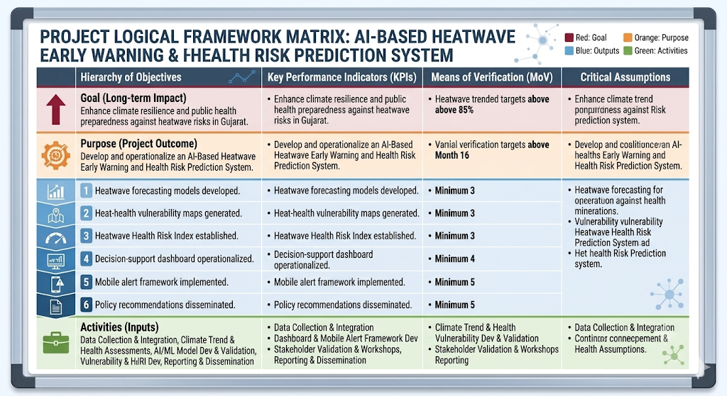

26. GANTT CHART
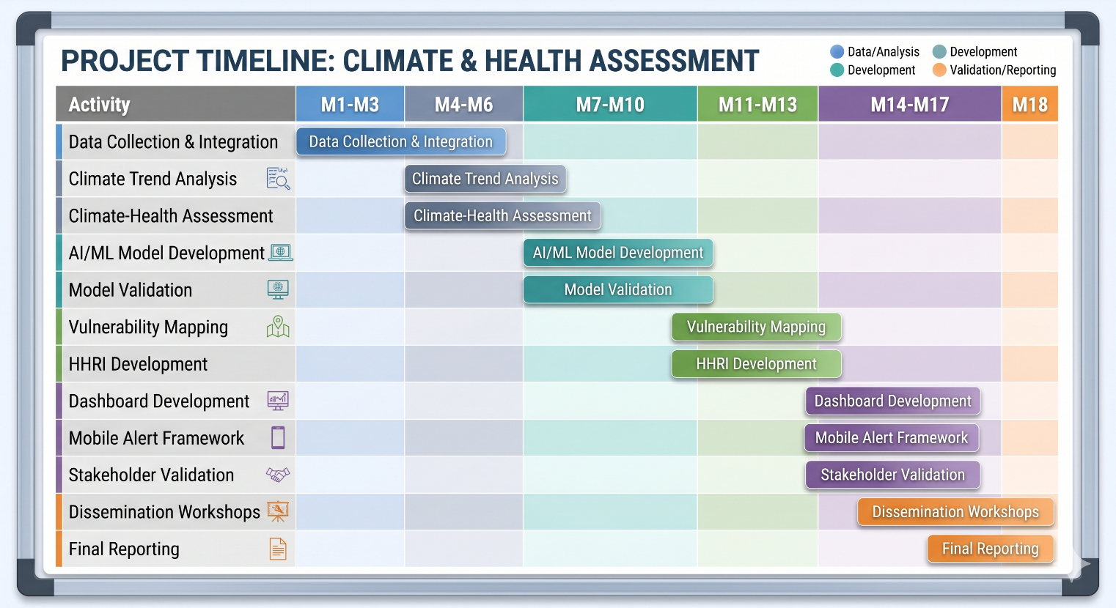

27. Details of Principal Investigator
Dr. Nisarg A Joshi (Ph.D.), Assistant Professor, Institute of Management, Nirma University
- 15 years of experience in climate finance, adaptation finance and econometric modelling
- Published numerous research articles in reputed National and International Journals
- PI for Nirma University-funded Projects
Email: nisarg.joshi@nirmauni.ac.in Phone: +91-9723500052
Details of Co-Principal Investigators
Co-PI: Dr. Ashwin Raiyani (Ph.D.), Associate Professor, Karnavati University
- 17 years of experience in the fields of Cloud Computing, Big Data Analytics, Data Science, Machine Learning, and Networking.
- Principal Investigator for the research project received a MODROB grant of Rs. 14.38 lakhs from AICTE under the AQIS scheme
- Principal investigator for Nirma University-funded project on “Cloud-Based Smart Greenhouse Monitoring System”
Email: ashwin.r@karnavatiuniversity.edu.in Phone: +91-8141542442

Co-PI: Dr. Shashank Thanki, Associate Professor, Institute of Management, Nirma University
- 25 years of teaching and research experience. His research interests lie at the intersection of sustainable manufacturing, Operational Excellence practices, sustainable supply chain management, and performance measurement frameworks.
- I have extensively worked on the application of multi-criteria decision-making (MCDM) tools and empirical research methods.
- My work supports evidence-based decision-making for manufacturing and service organizations striving for operational excellence and sustainability.
Email: shashank@nirmauni.ac.in Phone: +91-9099690094

Dr. Shachi Jatin Desai (Ph.D.), Assistant Professor, Institute of Management, Nirma University

- Over 4 years of combined experience in academia and the market research industry (Kantar, IMRB), with expertise in Marketing Management, Consumer Behaviour and Customer Engagement.
- Completed Ph.D. in Marketing from Nirma University with research on Service Stress, Negative Customer Engagement & Behavioural Outcomes: An Empirical Investigation.
- Published research in leading ABDC- and ABS-indexed international journals, including the Journal of Services Marketing, Journal of Retailing and Consumer Services, and Journal of Promotion Management.
- Recipient of the Gold Medal in Engineering.
Email: shachi.desai@nirmauni.ac.in Phone: +91-9106967132

28. Institutional Profile and Prior Experience
Nirma University, a premier interdisciplinary university in Gujarat, will anchor the project. The University has been actively engaged in climate impact research, environmental economics, and policy evaluation, with a focus on state-level implementation.
29. Ethical Declaration and Plagiarism Undertaking (signed)
We hereby certify that the aforesaid research project entitled " Forest-Based Livelihood Resilience and Ecosystem Services for Particularly Vulnerable Tribal Groups (PVTGs) in Gujarat: Pathways to Inclusive Climate Adaptation and Sustainable Development" will be carried out in strict compliance with ethical standards and requirements.

All information obtained during the research will be collected with the informed consent of participants and stakeholders, and in a manner that ensures confidentiality, privacy, and voluntariness. The research shall not include any activity that may lead to harm to persons, communities, or the environment.

We further undertake that the content included in this proposal and the work to be performed are original and free of any plagiarism. Correct citations and acknowledgements shall be provided for all sources, and secondary material employed will be collected from authentic and reliable archives. The final report will be checked for plagiarism using plagiarism detection software, and additional care will be taken to ensure academic integrity.

We are aware that any transgression of ethical standards or plagiarism norms will lead to project termination and/or legal and academic sanctions, as determined by the sponsoring organisation or affiliated institutions.

Principal Investigator:
Dr. Nisarg A Joshi

Signature: _____________________

Date: ___________________________

Co-Principal Investigator:
Dr. Ashwin Raiyani

Signature: _____________________

Date: ___________________________

Co-Principal Investigator:
Dr. Shashank Thanki

Signature: _____________________

Date: ___________________________

Co-Principal Investigator:
Dr. Shachi Desai

Signature: _____________________

Date: ___________________________

REFERENCES
Ahmedabad Municipal Corporation. (2023). Ahmedabad Heat Action Plan 2023. Ahmedabad Municipal Corporation.
Azhar, G. S., Mavalankar, D., Nori-Sarma, A., Rajiva, A., Dutta, P., Jaiswal, A., Sheffield, P., Knowlton, K., & Hess, J. J. (2014). Heat-related mortality in India: Excess all-cause mortality associated with the 2010 Ahmedabad heat wave. PLoS ONE, 9(3), e91831. https://doi.org/10.1371/journal.pone.0091831
Bunker, A., Wildenhain, J., Vandenbergh, A., Henschke, N., Rocklöv, J., Hajat, S., & Sauerborn, R. (2023). Machine learning approaches for heat-health risk prediction: A systematic review. Environmental Health Perspectives, 131(4), 47001–47018.
Breiman, L. (2001). Random forests. Machine Learning, 45(1), 5–32. https://doi.org/10.1023/A:1010933404324
Chen, T., & Guestrin, C. (2016). XGBoost: A scalable tree boosting system. Proceedings of the ACM SIGKDD International Conference on Knowledge Discovery and Data Mining, 785–794.
Ebi, K. L., Capon, A., Berry, P., Broderick, C., de Dear, R., Havenith, G., Honda, Y., Kovats, R. S., Ma, W., & Malik, A. (2021). Hot weather and heat extremes: Health risks. The Lancet, 398(10301), 698–708.
Fotheringham, A. S., Brunsdon, C., & Charlton, M. (2002). Geographically weighted regression: The analysis of spatially varying relationships. Wiley.
Gasparrini, A., Guo, Y., Hashizume, M., Lavigne, E., Zanobetti, A., Schwartz, J., Tobias, A., Tong, S., Rocklöv, J., Forsberg, B., Leone, M., De Sario, M., Bell, M. L., Guo, Y. L., Wu, C. F., Kan, H., Yi, S. M., Coelho, M. S., Saldiva, P. H., & Armstrong, B. (2015). Mortality risk attributable to high and low ambient temperature. The Lancet, 386(9991), 369–375.
Hajat, S., O'Connor, M., & Kosatsky, T. (2010). Health effects of hot weather: From awareness of risk factors to effective health protection. The Lancet, 375(9717), 856–863.
Harlan, S. L., Declet-Barreto, J. H., Stefanov, W. L., & Petitti, D. B. (2013). Neighborhood effects on heat deaths: Social and environmental predictors of vulnerability. Environmental Health Perspectives, 121(2), 197–204.
Hess, J. J., Saha, S., & Luber, G. (2018). Summertime acute heat illness in India and the effectiveness of heat action plans. Environmental Research Letters, 13(12), 123001.
Intergovernmental Panel on Climate Change (IPCC). (2023). Climate Change 2023: Synthesis Report. Geneva: IPCC.
India Meteorological Department. (2024). Annual climate summary and heatwave assessment report. Ministry of Earth Sciences, Government of India.
Kikon, N., Singh, P., Singh, S. K., & Vyas, A. (2016). Assessment of urban heat islands in Indian cities using remote sensing. Journal of Environmental Management, 183, 880–894.
Knowlton, K., Kulkarni, S. P., Azhar, G. S., Mavalankar, D., Jaiswal, A., Connolly, M., Nori-Sarma, A., Rajiva, A., Dutta, P., Deol, B., & Hess, J. J. (2014). Development and implementation of South Asia’s first heat-health action plan in Ahmedabad. International Journal of Environmental Research and Public Health, 11(4), 3473–3492.
Laaidi, K., Zeghnoun, A., Dousset, B., Bretin, P., Vandentorren, S., Giraudet, E., & Beaudeau, P. (2012). The impact of heat islands on mortality in Paris during the 2003 heat wave. Environmental Health Perspectives, 120(2), 254–259.
Li, Y., Zhang, H., Zhao, X., & Wang, J. (2022). Deep learning-based prediction of extreme heat events using long short-term memory networks. Climate Dynamics, 59(7–8), 2311–2327.
Lowe, D., Ebi, K. L., & Forsberg, B. (2011). Heatwave early-warning systems and adaptation advice to reduce human health impacts. International Journal of Environmental Research and Public Health, 8(12), 4623–4648.
Lundberg, S. M., & Lee, S. I. (2017). A unified approach to interpreting model predictions. Advances in Neural Information Processing Systems, 30, 4765–4774.
Malczewski, J. (2006). GIS-based multicriteria decision analysis: A survey of the literature. International Journal of Geographical Information Science, 20(7), 703–726.
Mishra, V., Ganguly, A. R., Nijssen, B., & Lettenmaier, D. P. (2020). Changes in observed climate extremes in India. Nature Climate Change, 10(4), 311–317.
Mora, C., Dousset, B., Caldwell, I. R., Powell, F. E., Geronimo, R. C., Bielecki, C. R., Counsell, C. W., Dietrich, B. S., Johnston, E. T., Louis, L. V., Lucas, M. P., McKenzie, M. M., Shea, A. G., Tseng, H., Giambelluca, T. W., Leon, L. R., Hawkins, E., & Trauernicht, C. (2017). Global risk of deadly heat. Nature Climate Change, 7(7), 501–506.
National Disaster Management Authority. (2023). National guidelines for preparation of action plan – Prevention and management of heatwaves—Government of India.
Nori-Sarma, A., Sun, S., Sun, Y., Spangler, K. R., & Bell, M. L. (2019). Heat-related mortality in India: Current evidence and future directions. Environmental Research, 177, 108587.
Pörtner, H. O., Roberts, D. C., Tignor, M., Poloczanska, E. S., Mintenbeck, K., Alegría, A., Craig, M., Langsdorf, S., Löschke, S., Möller, V., Okem, A., & Rama, B. (2022). Climate Change 2022: Impacts, Adaptation and Vulnerability. Cambridge University Press.
Qin, Y., Song, D., Chen, H., Cheng, W., Jiang, G., & Cottrell, G. W. (2017). A dual-stage attention-based recurrent neural network for time-series prediction. Proceedings of IJCAI, 2627–2633.
Reichstein, M., Camps-Valls, G., Stevens, B., Jung, M., Denzler, J., Carvalhais, N., & Prabhat. (2019). Deep learning and process understanding for data-driven Earth system science. Nature, 566(7743), 195–204.
Reid, C. E., O'Neill, M. S., Gronlund, C. J., Brines, S. J., Brown, D. G., Diez-Roux, A. V., & Schwartz, J. (2009). Mapping community determinants of heat vulnerability. Environmental Health Perspectives, 117(11), 1730–1736.
Rohini, P., Rajeevan, M., & Srivastava, A. K. (2016). On the variability and increasing trends of heat waves over India. Scientific Reports, 6, 26153.
Sharma, A., & Mujumdar, P. P. (2021). Heatwave risk and adaptation in South Asia: A review. Climate Risk Management, 33, 100347.
Singh, C., Pathak, A., Basu, R., & Jha, S. (2023). Evaluation of heat action plans in India: Progress, challenges, and opportunities. Climate Policy, 23(8), 1032–1048.
State Action Plan on Climate Change – Gujarat. (2024). Climate Change Department, Government of Gujarat.
Toloo, G., FitzGerald, G., Aitken, P., Verrall, K., & Tong, S. (2013). Are heat warning systems effective? Environmental Health, 12(1), 27.
United Nations. (2024). Sustainable Development Goals Report 2024. United Nations.
United Nations Environment Programme. (2023). Adaptation Gap Report 2023. UNEP.
Weng, Q., Lu, D., & Schubring, J. (2004). Estimation of land surface temperature–vegetation abundance relationship for urban heat island studies. Remote Sensing of Environment, 89(4), 467–483.
World Health Organization. (2023). Protecting health from climate change: Heat and health technical guidance. WHO.
World Meteorological Organization. (2024). State of the Global Climate 2024. WMO.
Xu, Z., FitzGerald, G., Guo, Y., Jalaludin, B., & Tong, S. (2020). Impact of heatwave prediction models on public health risk assessment. Environmental International, 138, 105646.
Zhao, L., Oppenheimer, M., Zhu, Q., Baldwin, J. W., Ebi, K. L., Bou-Zeid, E., Guan, K., & Liu, X. (2018). Interactions between urban heat islands and heat waves. Nature Climate Change, 8(12), 1099–1105.

ANNEXURE I: DETAILED ACTIVITY-WISE BUDGET & JUSTIFICATION
DETAILED ACTIVITY-WISE BUDGET & JUSTIFICATION
Project: AI-Based Heatwave Early Warning and Health Risk Prediction System in Gujarat
A. HUMAN RESOURCES
Research Associate – Climate Science & AI  • Climate data processing, heatwave modelling, AI/ML model development, forecast validation, and documentation. | ₹40,000 / month × 18 months | ₹ 7,20,000.00
Research Associate – GIS & Public Health  • Spatial data processing, vulnerability mapping, GIS analysis, public-health integration, and heat-health index development. | ₹35,000 / month × 18 months | ₹ 6,30,000.00
Data Analyst  • Data cleaning, database management, data integration, quality assurance, and dashboard data pipelines. | ₹25,000 / month × 18 months | ₹ 4,50,000.00
Project Coordinator  • Administrative coordination, financial documentation, workshop organization, and stakeholder communication. | ₹20,000 / month × 18 months | ₹ 3,60,000.00
Subtotal: A. HUMAN RESOURCES |  | ₹ 21,60,000.00
B. DATA ACQUISITION AND PROCESSING  • Acquisition, conversion, cleaning, standardization, metadata preparation, storage, and quality control for integrated database creation. | Lump Sum allocation for specialized datasets | ₹ 2,50,000.00
C. CLOUD INFRASTRUCTURE AND COMPUTING  • Provisioning of cloud servers, GPU processing nodes, high-capacity storage, backup systems, dashboard hosting, and API service pipelines. | Estimated multi-month cloud resource consumption | ₹ 3,50,000.00
D. GIS, VISUALIZATION AND ANALYTICAL SOFTWARE  • Procurement of specialized GIS extensions, remote sensing tools, enterprise visualization platforms, and security solutions. | Software license & access requirements | ₹ 2,00,000.00
E. DASHBOARD DEVELOPMENT  • Core UI/UX design, front-end interface builds, back-end computational logic integration, map engine APIs, user testing, and deployment. | Operational deliverable allocation | ₹ 4,00,000.00
F. MOBILE ALERT SYSTEM DEVELOPMENT  • Development of trigger alert logic, SMS gateway integration, communication template management, mobile view optimizations, and stress testing. | Dissemination infrastructure build | ₹ 1,50,000.00
G. FIELD VALIDATION AND STAKEHOLDER CONSULTATIONS  • Conducting district-level local consultations, expert interviews, validation workshops, cross-department alignment meetings, and field travel. | Logistics, travel, & workshop venue frameworks | ₹ 2,50,000.00
H. CAPACITY BUILDING AND TRAINING  • Executing specialized training workshops targeting municipal government officials, public health personnel, urban local bodies, and disaster agencies. | Sustainability training programs | ₹ 1,50,000.00
I. PUBLICATIONS AND DISSEMINATION  • Compiling policy briefs, technical reports, open-access journal publication processing charges, and scientific conference presentations. | Knowledge transfer & brief productions | ₹ 1,50,000.00
J. INSTITUTIONAL OVERHEADS  • Shared administrative infrastructure, high-speed internet networks, core utilities, office support space, financial accounting, audits, and compliance. | Institutional support framework (fixed allocation) | ₹ 2,00,000.00
GRAND TOTAL PROJECT BUDGET |  | ₹ 42,60,000.00

ANNEXURE II: MONITORING AND EVALUATION MATRIX
Objective | Indicator | Baseline | Target | Verification
Develop a heatwave forecasting model | Forecast accuracy | Not available | >85% | Validation report
Create vulnerability maps | District coverage | 0 | 10+ districts | GIS outputs
Develop HHRI | Index developed | No | Yes | Technical report
Build dashboard | Operational platform | No | Yes | Dashboard deployment
Mobile alerts | Alert framework | No | Yes | System testing
Capacity building | Participants trained | 0 | 100+ | Attendance records
Policy engagement | Policy briefs | 0 | 5 | Published briefs
Scientific outputs | Publications | 0 | 3+ | Journal submissions

Monitoring activities will be conducted quarterly and reviewed through Steering Committee meetings to ensure timely implementation and achievement of project objectives.

ANNEXURE III: PROJECT ORGANOGRAM

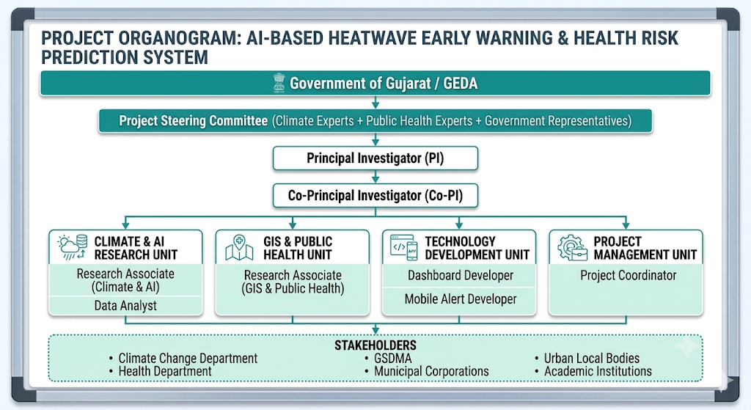

ANNEXURE IV: DASHBOARD ARCHITECTURAL DIAGRAM

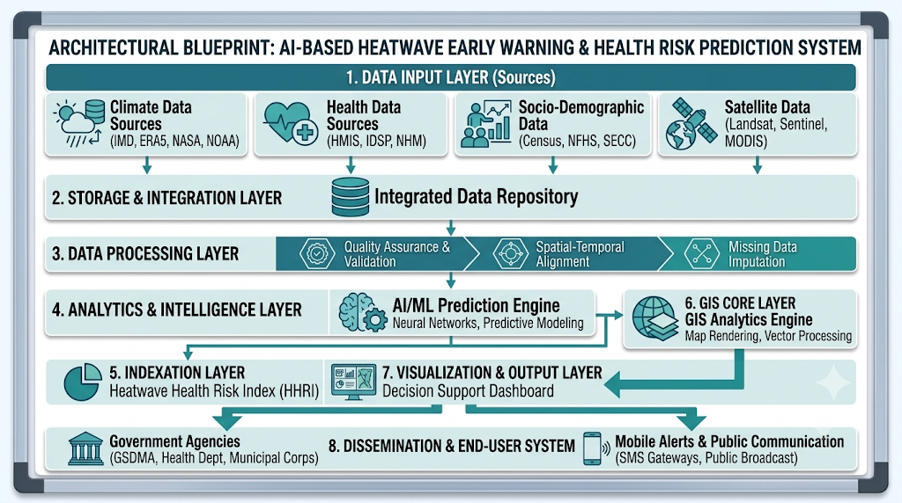

ANNEXURE V: CONCEPTUAL FRAMEWORK FIGURE

